- Write a single ansible playbook which will install apache and nginx. Note: Playbook should not be hardcoded and pass the variables from different file.
Create a file in controller vars.yml
---
web_packages:
- apache2
- nginx
Playbook:
---
- name: Install Apache and Nginx using variables
hosts: node-1
become: yes
vars_files:
- vars.yml
tasks:
- name: Install web server packages
apt:
name: "{{ item }}"
state: latest
update_cache: yes
loop: "{{ web_packages }}"
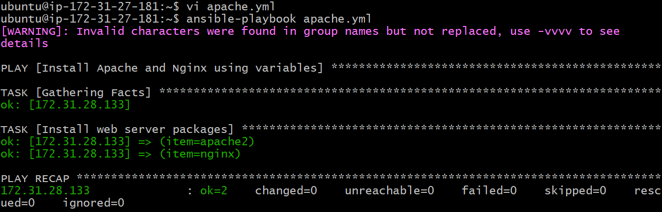
Test-1 on port-80:
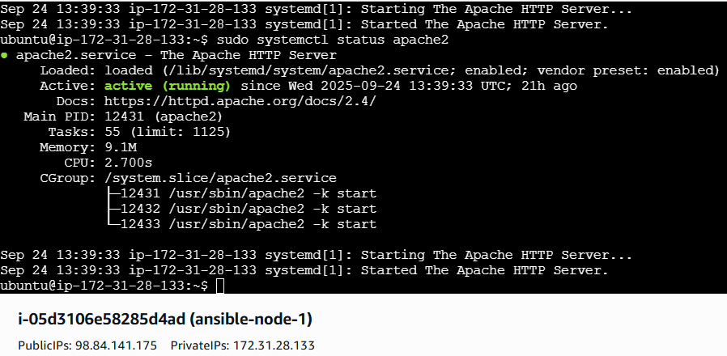
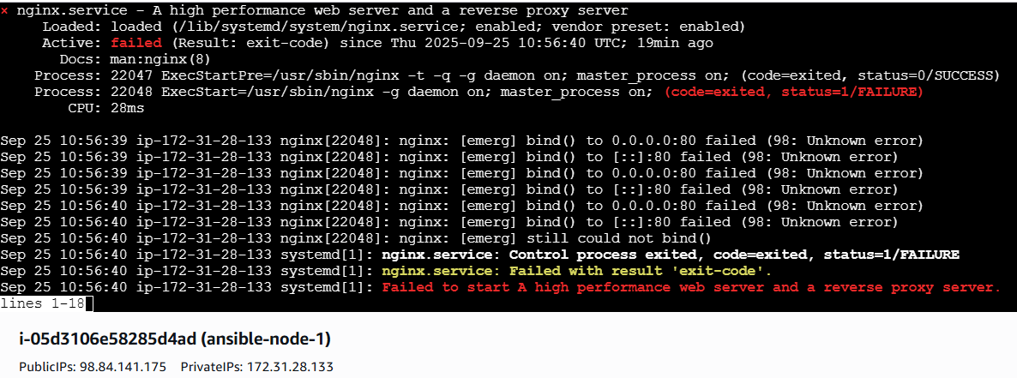
Test-2 on port-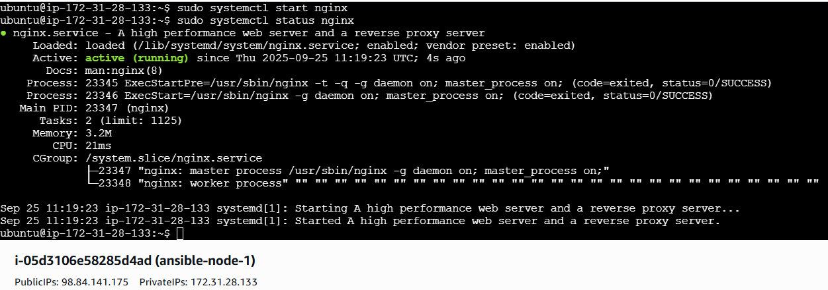
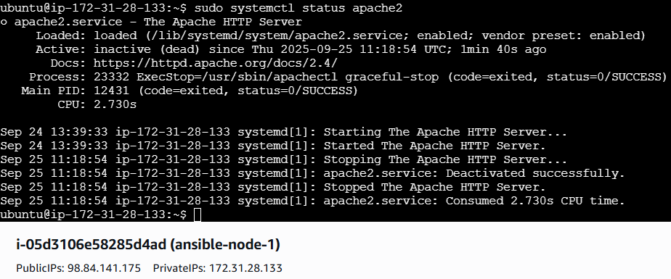

- Ansible playbook to create 10 different directories with minimal code and directory names should be passed as variables.
Create a file in controller dirs.yml
---
dir_list:
- /opt/dir1
- /opt/dir2
- /opt/dir3
- /opt/dir4
- /opt/dir5
- /opt/dir6
- /opt/dir7
- /opt/dir8
- /opt/dir9
- /opt/dir10
Playbook:
---
- name: Create multiple directories
hosts: node-1
become: yes
vars_files:
- dirs.yml
tasks:
- name: Create directories from variable list
file:
path: "{{ item }}"
state: directory
mode: '0755'
loop: "{{ dir_list }}"
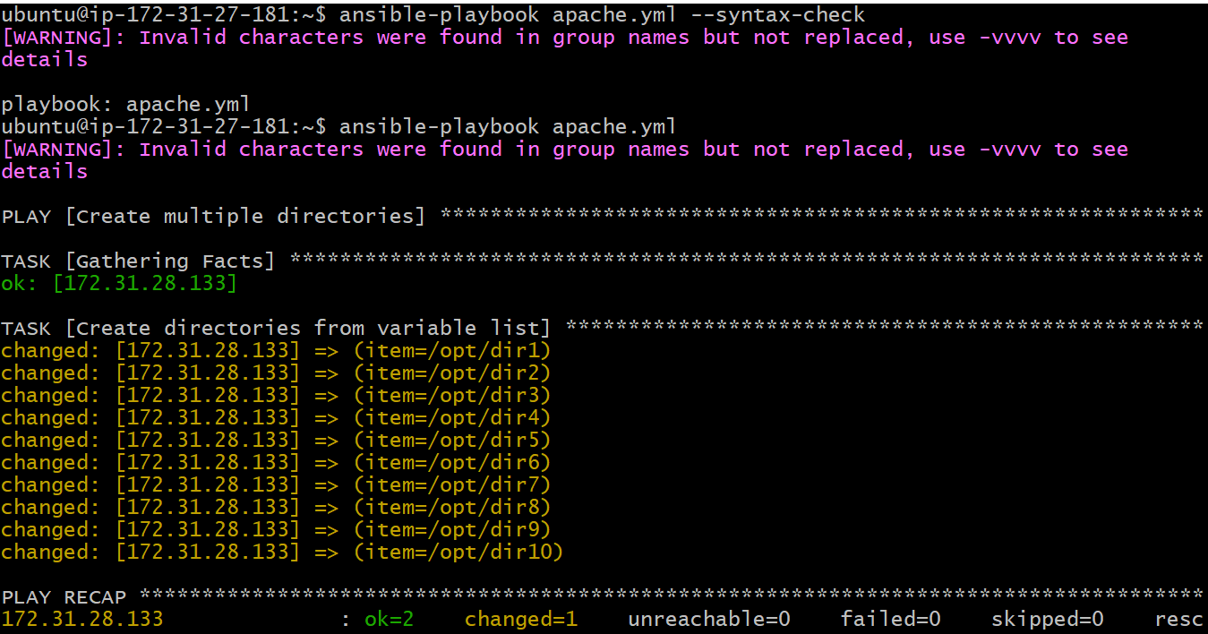
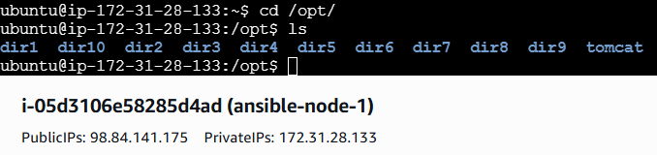
- Ansible playbook to copy ssh-keygen from master to worker nodes. Note: a)Provision new 3 ec2 machines, one master and two worker nodes. b)Create common user called ansadm and provide sudo priviliges on 3 ec2 instances. c)Create ssh-keygen in master and your playbook should copy the keygen making it password less authentication.
Provision 3 ec2 instances:
Create file (provision_ec2.yml) then write playbook script
Playbook script:
---
- name: Provision EC2 instances
hosts: localhost
connection: local
gather_facts: false
vars:
region: us-east-1 # Change to your AWS region
key_name: ubuntu2 # Updated key name
instance_type: t2.micro # Updated instance type
ami_id: ami-0360c520857e3138f # Amazon ubuntu AMI
vpc_id: vpc-xxxxxxxx # Optional: your VPC ID
tasks:
- name: Launch master instance
amazon.aws.ec2_instance:
name: master
key_name: "{{ key_name }}"
instance_type: "{{ instance_type }}"
image_id: "{{ ami_id }}"
region: "{{ region }}"
wait: yes
register: master_instance
- name: Launch worker1 instance
amazon.aws.ec2_instance:
name: worker1
key_name: "{{ key_name }}"
instance_type: "{{ instance_type }}"
image_id: "{{ ami_id }}"
region: "{{ region }}"
wait: yes
register: worker1_instance
- name: Launch worker2 instance
amazon.aws.ec2_instance:
name: worker2
key_name: "{{ key_name }}"
instance_type: "{{ instance_type }}"
image_id: "{{ ami_id }}"
region: "{{ region }}"
wait: yes
register: worker2_instance
- name: Show EC2 instance details
debug:
msg:
- "Master Public IP: {{ master_instance.instances[0].public_ip_address }}"
- "Worker1 Public IP: {{ worker1_instance.instances[0].public_ip_address }}"
- "Worker2 Public IP: {{ worker2_instance.instances[0].public_ip_address }}"
Hosts.yml
- name: Add EC2 instances to dynamic inventory
hosts: localhost
connection: local
gather_facts: false
vars:
master_ip: "MASTER_PUBLIC_IP"
worker1_ip: "WORKER1_PUBLIC_IP"
worker2_ip: "WORKER2_PUBLIC_IP"
ssh_key_path: "~/.ssh/ubuntu2.pem"
tasks:
- name: Add master to inventory
add_host:
name: master
ansible_host: "{{ master_ip }}"
ansible_user: ec2-user
ansible_ssh_private_key_file: "{{ ssh_key_path }}"
groups: master

- name: Add workers to inventory
add_host:
name: "{{ item.name }}"
ansible_host: "{{ item.ip }}"
ansible_user: ec2-user
ansible_ssh_private_key_file: "{{ ssh_key_path }}"
groups: workers
loop:
- { name: worker1, ip: "{{ worker1_ip }}" }
- { name: worker2, ip: "{{ worker2_ip }}" }
Create ansadm user and SSH keypair for ansadm
Ansadmuser.yml:
---
- name: Setup ansadm user and directories on all nodes
hosts: master:workers
become: yes
tasks:
- name: Ensure ansadm user exists
ansible.builtin.user:
name: ansadm
shell: /bin/bash
create_home: yes
- name: Ensure .ssh directory exists for ansadm
ansible.builtin.file:
path: /home/ansadm/.ssh
state: directory
owner: ansadm
group: ansadm
mode: '0700'
- name: Allow ansadm passwordless sudo
ansible.builtin.copy:
dest: /etc/sudoers.d/ansadm
content: "ansadm ALL=(ALL) NOPASSWD:ALL\n"
owner: root
group: root
mode: '0440'
- name: Generate SSH key on Master
hosts: master
become: yes
vars:
ssh_key_file: /home/ansadm/.ssh/id_rsa
tasks:
- name: Generate SSH keypair for ansadm
ansible.builtin.openssh_keypair:
path: "{{ ssh_key_file }}"
type: rsa
owner: ansadm
group: ansadm
mode: '0600'
register: ssh_key
- name: Add public key to master's authorized_keys
ansible.builtin.authorized_key:
user: ansadm
key: "{{ ssh_key.public_key }}"
- name: Copy Master's Public Key to Workers
hosts: workers
become: yes
vars:
master_pub_key: "{{ hostvars['master']['ssh_key'].public_key }}"
tasks:
- name: Add master's public key to worker authorized_keys
ansible.builtin.authorized_key:
user: ansadm
key: "{{ master_pub_key }}"
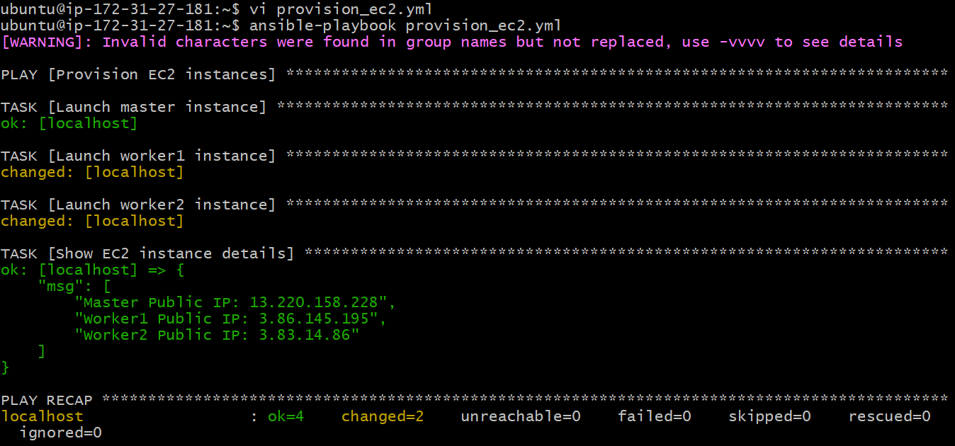
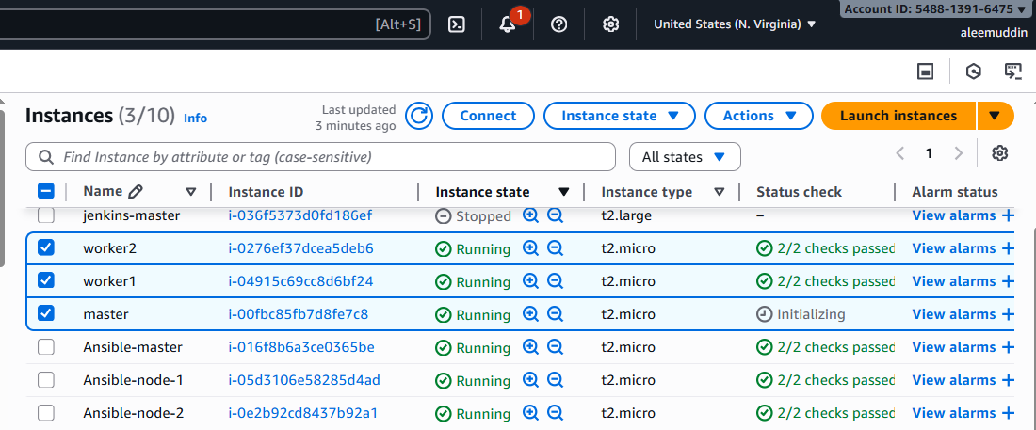
Vi hosts.ini
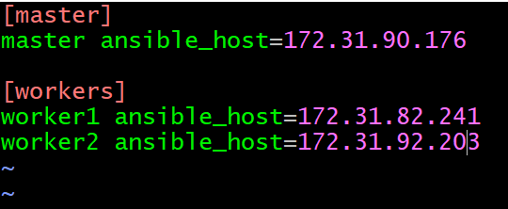
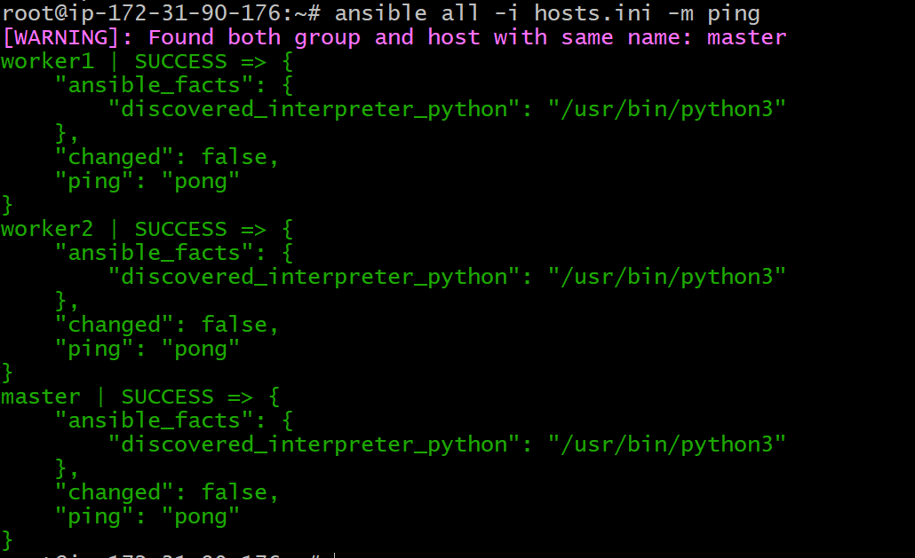
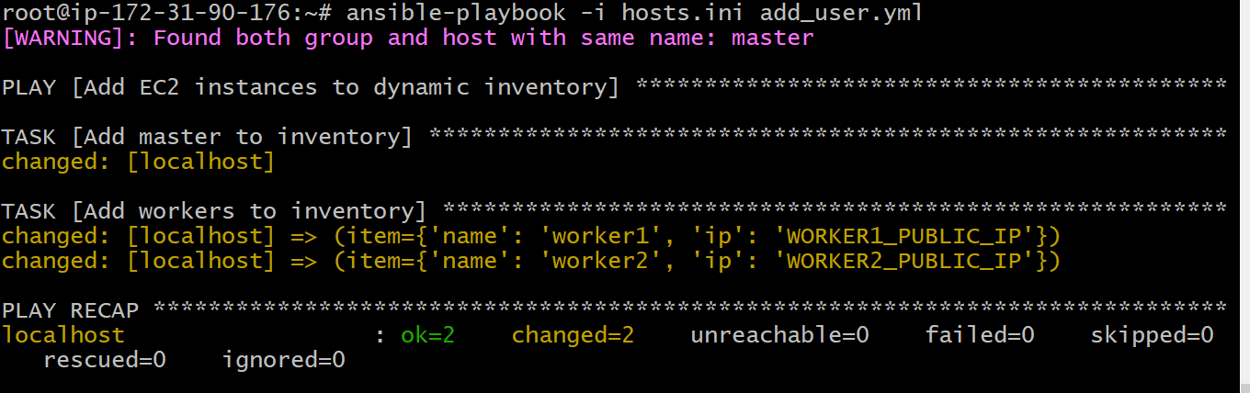
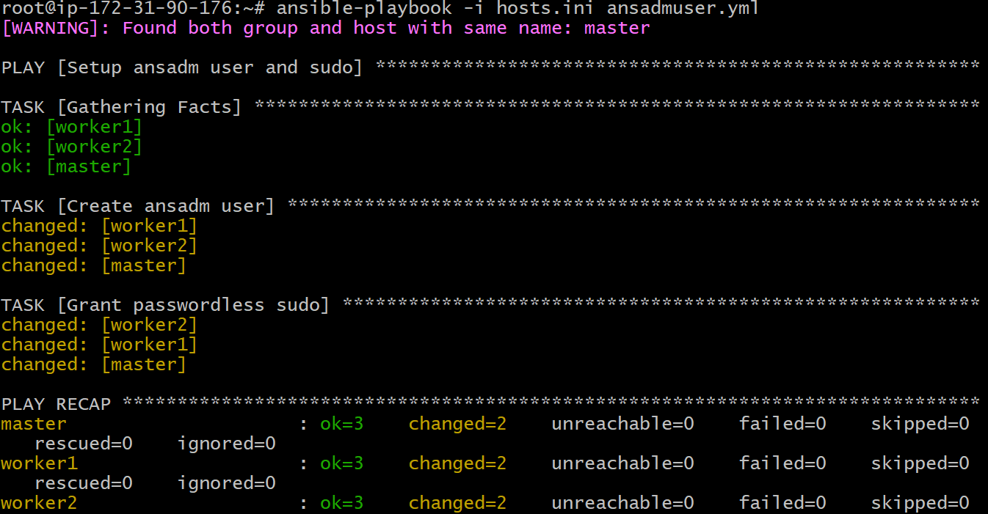
Switch to ansadm user:
sudo su – ansadm
ssh ansadm@ <public-ip>
master
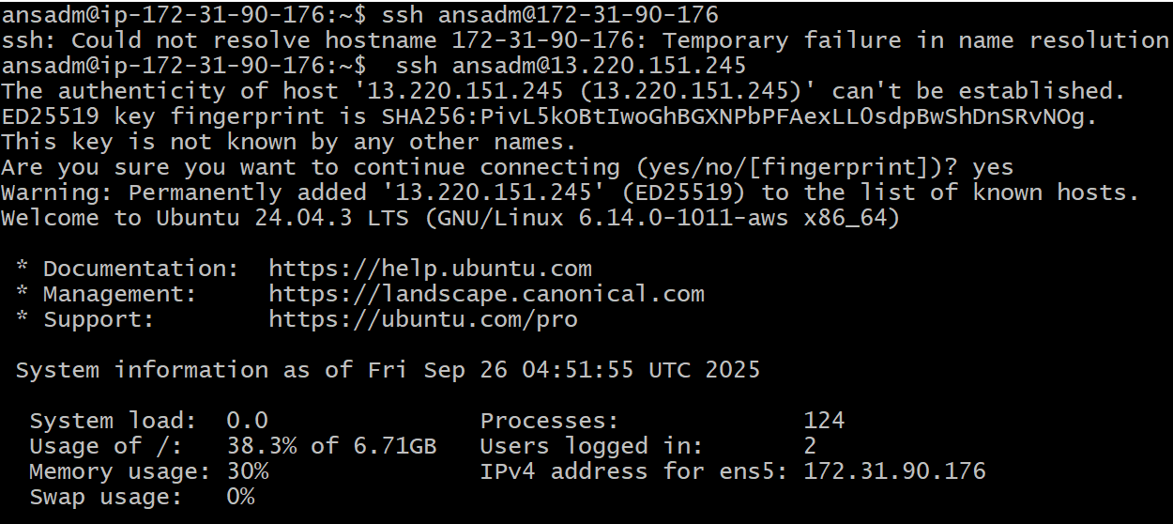
Worker1
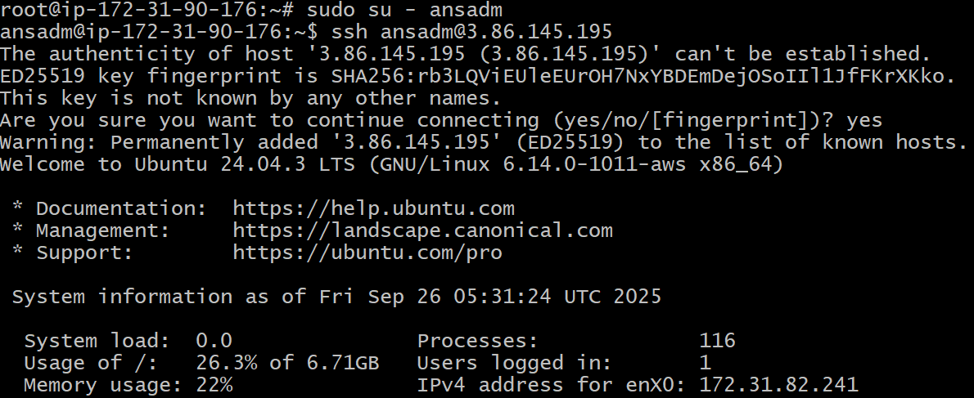
Worker2
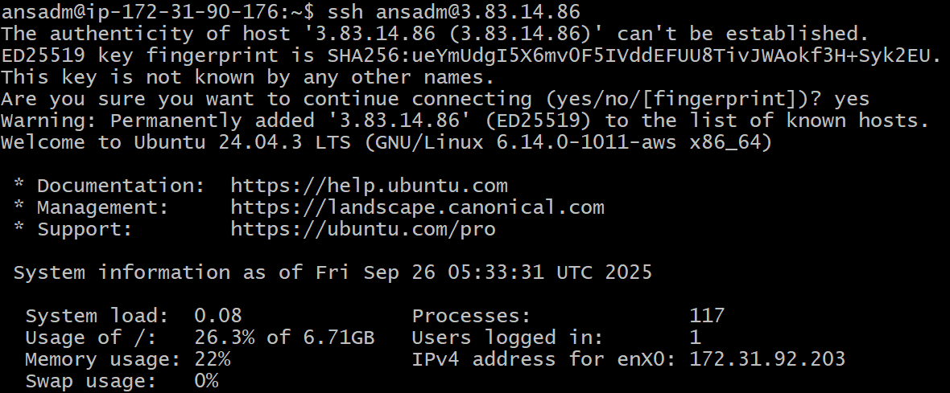

- Ansible playbook to inject ansible vault variables.
Run this command
ansible-vault create vault.yml
set new password
create one yml
vi use_vault.yml
---
- name: Inject vault variables
hosts: localhost
become: yes
vars_files:
- vault.yml
tasks:
- name: Show DB credentials (for demo only, don’t do in real!)
debug:
msg: "User={{ vault_db_user }} Password={{ vault_db_password }}"
- name: Create config file with vault variables
copy:
dest: /etc/myapp.conf
content: |
[database]
user={{ vault_db_user }}
password={{ vault_db_password }}
